Names: Ismail Hussain, Omar Abdullah
Date: 31/10/2022
Lab Section: D22
Lab Instructor: Shuren Wang

Lab 2 – Combinational Logic Design

Abstract:
The purpose of this experiment was to gain an understanding of MUX’s, DEMUX’S, and implementing combinational logic circuits using Xilinx Zybo Z7 FPGA development board with Xilinx Vivado software. This experiment can be divided into two parts. The first part consists of constructing a MUX to specify the specific signal to be sent on a transmission line depending on the input received by 3 antennas. Then construct a DEMUX to send said signal to one of three respective engineers. This is significant as the ability construct a MUX and DEMUX to filter and select specific signals is what allows computers to respond to input in real time. The second part of this experiment was to use Vivado software to construct a program that would implement two factor authentication into a security system for lab rooms through the Xilinx Zybo Z7 FGPA hardware. This is significant as it represents the ability to implement combination logic circuits into real world applications.

Introduction:
There were two main objectives in this lab. The first was to construct a MUX and DEMUX system that would theoretically mimic how to optimally select a desired transmission signal and deliver it to an engineer who could properly process that data. To do this, algebraic expressions for the MUX, DEMUX, and output where constructed. Then a truth table was constructed to represent it. The fundamental use of a MUX is to select a single output from multiple inputs. This is incredibly useful as it allows computers to sift through large amounts of data and process the correct information. In contrast a DEMUX takes a single input and decides which output out of multiple outputs to send it to. This is also incredibly useful as it allows computers to properly send specific data to where it needs to go. For our theoretical experiment specifically, it is very useful as it allows our computer to select a single input from multiple antennas and direct that single data stream to one specific engineer out of three. Our second objective was to construct a security system for two rooms, lab (0) and lab(1), in addition to a security alarm. To do this we used the Xilinx Zybo Z7 FPGA development board and Xilinx Vivado software. More specifically, we were to set up a two-factor authentication system where people who wished to access the room needed to input a specific password and swipe the appropriate card. In order to do this, we created a truth table with 5 inputs and 3 outputs to represent all the possible scenarios that could occur when interacting with the security system. Simplified algebraic expressions were then obtained from this table and were then finally represented as logic circuits. This provided us the information needed to create a code in Vivado to represent the security system. Which we then tested out using the Xilinx Zybo Z7 FPGA development board. This applied the basic principles of truth tables and logic circuits to design a real-world application of security systems.

Design Section
In this lab there were three things we had to design for the security system. We had to design a logic circuit for the lab (0), a logic circuit for lab (1), and the alarm. In order to obtain these logic circuits, the following truth table seen in figure 1 was constructed. For this truth table we had three inputs: are C (0), C(1), K(0), K(1), K(2). The ‘C’ represents the card number for either lab 0 or lab 2. The ‘K’ represents a digit of the password required to to gain access to the lab. The outputs are naturally alarm, lab 0, and lab 1. From that truth table the expressions for lab (0) were produced and simplified to: [C(0)]’[C(1)] [K(0)][K(2)]’. For lab (1) the simplified expression: [C(0)][C(1)]’[K(0)]’[K(2)] was obtained. Finally for alarm the expression simplified to: [C(1)][K(0)]’ + [C(0)][K(2)]’ + [C(1)][K(2)] + [C(0)][K(1)]. From these expressions the logic gates seen in figures 2, 3 and 4 were produced.
Table 1: Shows all possible iterations of the security system. The inputs are C(0), C(1), K(0), K(1), K(2). The outputs are alarm, Lab 0, and lab 1.
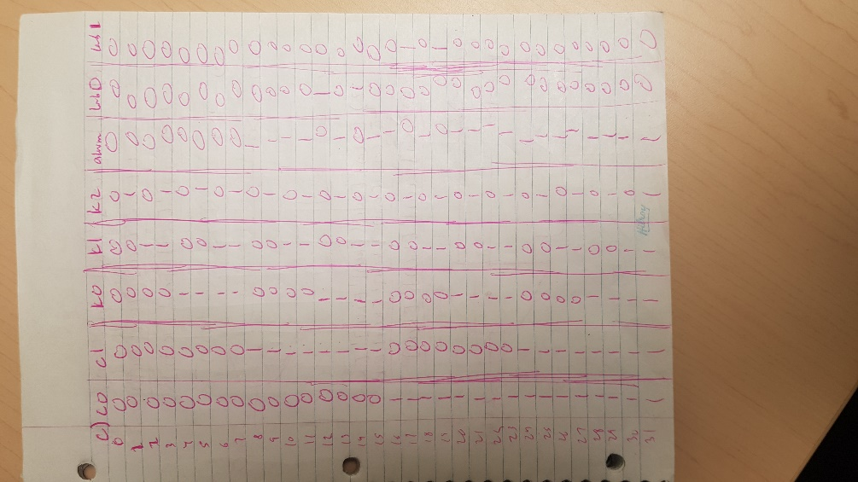

Table 2: A logic diagram for Lab (0). The inputs are C (0), C(1), K(0), K(1), K(2). The outputs are alarm, Lab 0, and lab 1.
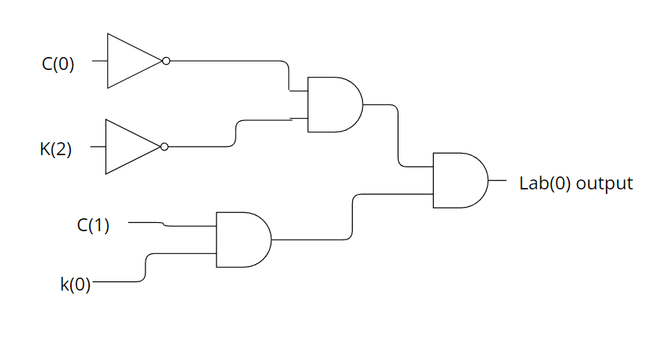
Table 3: A logic diagram for Lab (1). The inputs are C (0), C(1), K(0), K(1), K(2). The outputs are alarm, Lab 0, and lab 1.
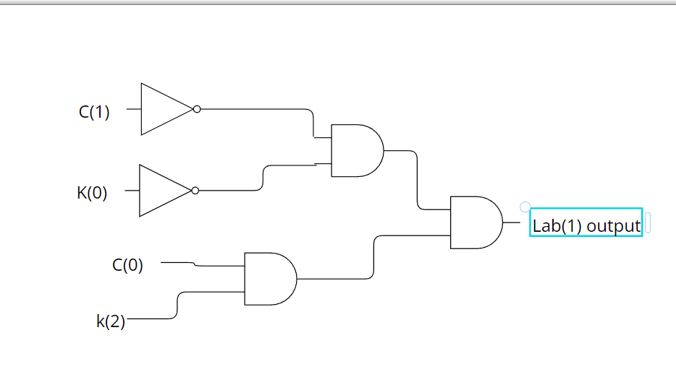
Table 4: A logic diagram for alarm. The inputs are C (0), C(1), K(0), K(1), K(2). The outputs are alarm, Lab 0, and lab 1.
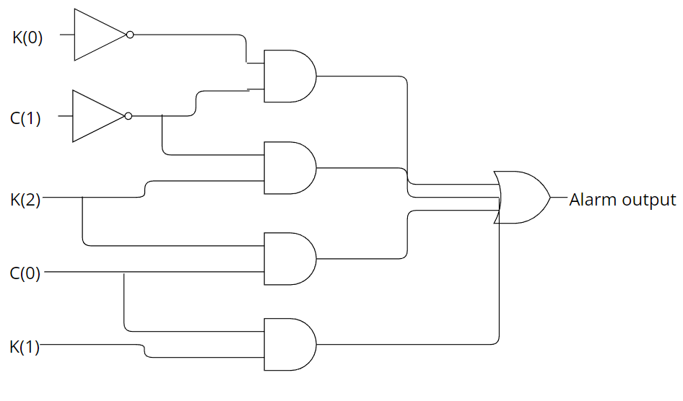

Experimental Procedure and Equipment:
The materials used in the experiment are as follows:
- Vivado Software
- Xilinx Zybo Z7 FPGA development board
The following Procedure was used to complete this lab:
- In the first part of the lab, you are to design something for NASA:
- To create a system that test a 3- input/1-output MUX and an accompanying 1- input/3-output DEMUX using AND, OR, and inverter gates. Create a MUX, DEMUX, and output truth table using the given parameters.
- From this truth table establish respective equations for the MUX, DEMUX, and engineer output
- Thus you have doneTime-Division Multiplexing
- For the second part of the lab: Construct a truth table for the security system using the parameters given in the lab. Use C(0), C(1), K(0), K(1), K(2) as the inputs to represent card 0, card 1, first digit of password, second digit of password, and third digit of password respectively. Implement alarm, Lab(0), and lab(1) as the outputs representing the security alarm, lab(0) being open or closed, and lab(1) being open or closed respectively.
- From said truth table extract algebraic expressions for the alarm, lab(0), and lab(1)
- Next produce a logic circuit from said expressions, similar to the ones seen in the experimental design section.
- Implement you designs into Vivado by converting the Boolean expressions into Vivado syntax
- Run a synthesis of this code and obtain the test cases

Results:

Figure 1: A result of our test cases for test bench one which consisted of our MUX and Demux system. I is the input from the antenna, S is the signal on the transmission line, DS is the signal on the DEMUX, E is the engineer output, and O is the signal output.
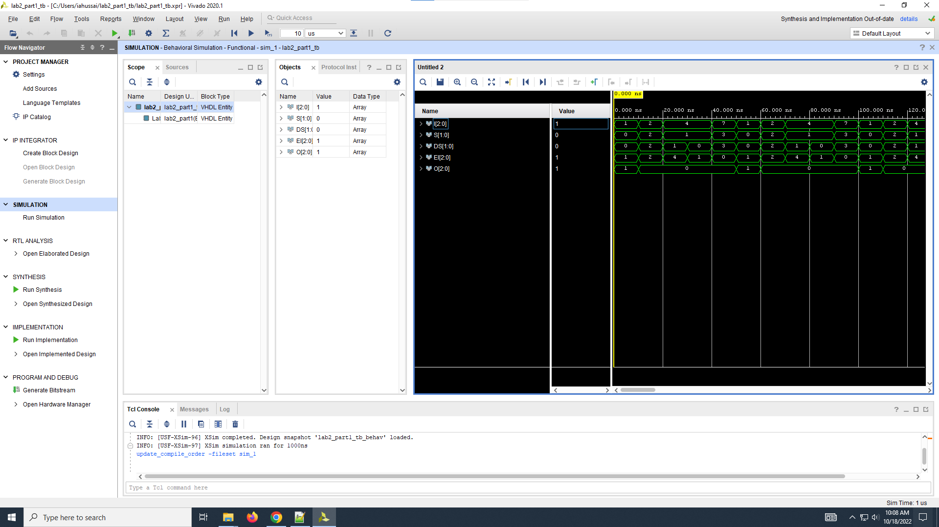
Figure 2: A result of our test cases for test bench two which consisted of our security system for the lab rooms. C is the card number, K is the digits of the password, Alarm represents the alarm signal for when an incorrect authentication occurs, LAB 0_unlock represents whether the proper authentication for lab room 0 was done, and , LAB 1_unlock represents whether the proper authentication for lab room 0 was done
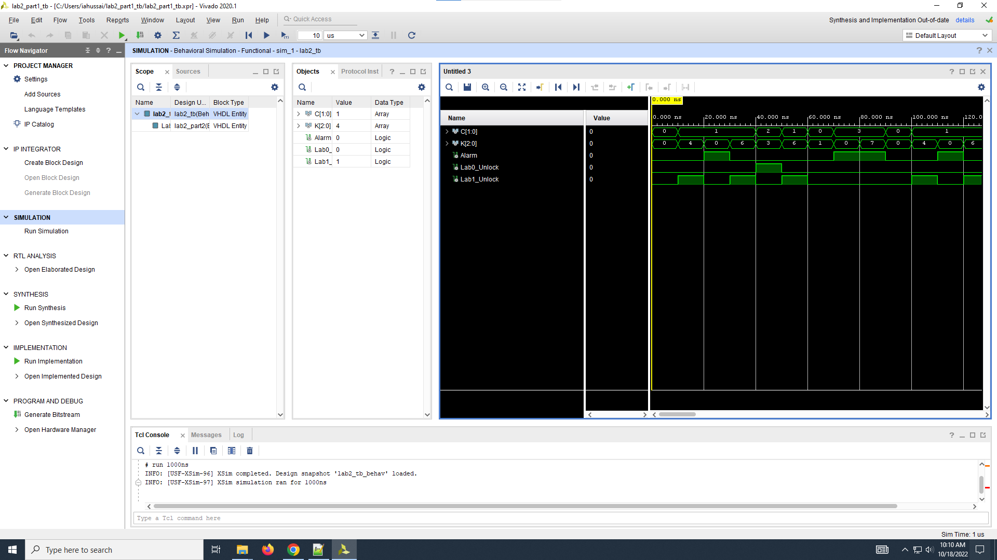
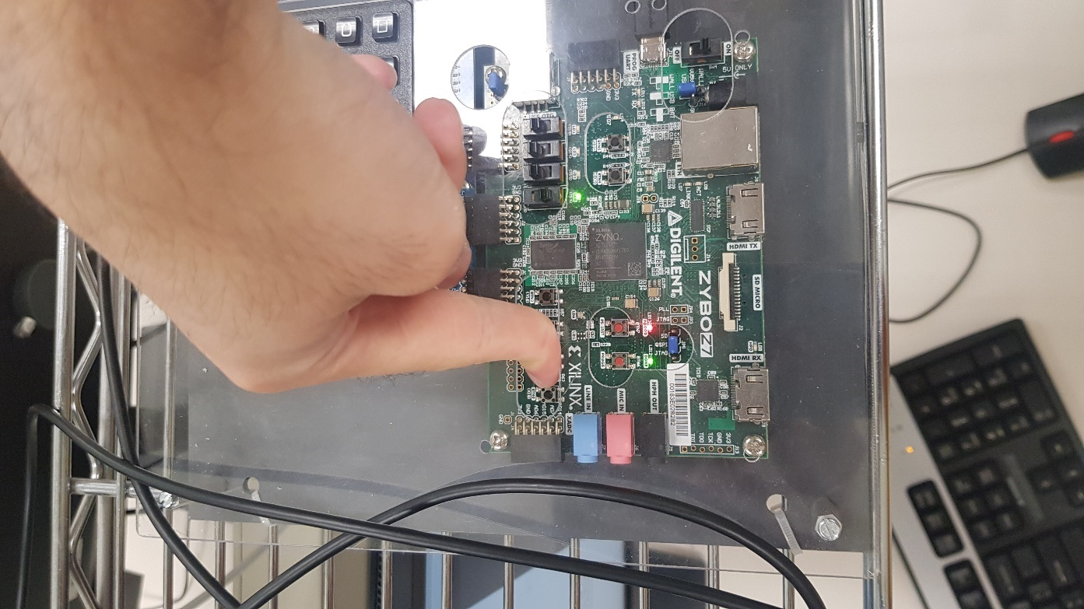
Figure 3: In this figure as you can see the security system displays a green light indicating that the proper password and card have been swiped
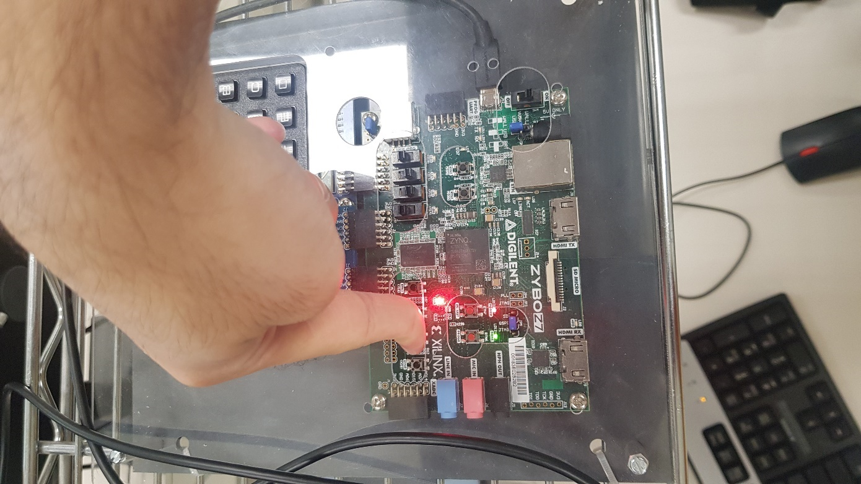
Figure 4: In this figure as you can see the security system displays a red light indicating that the incorrect password and card were used
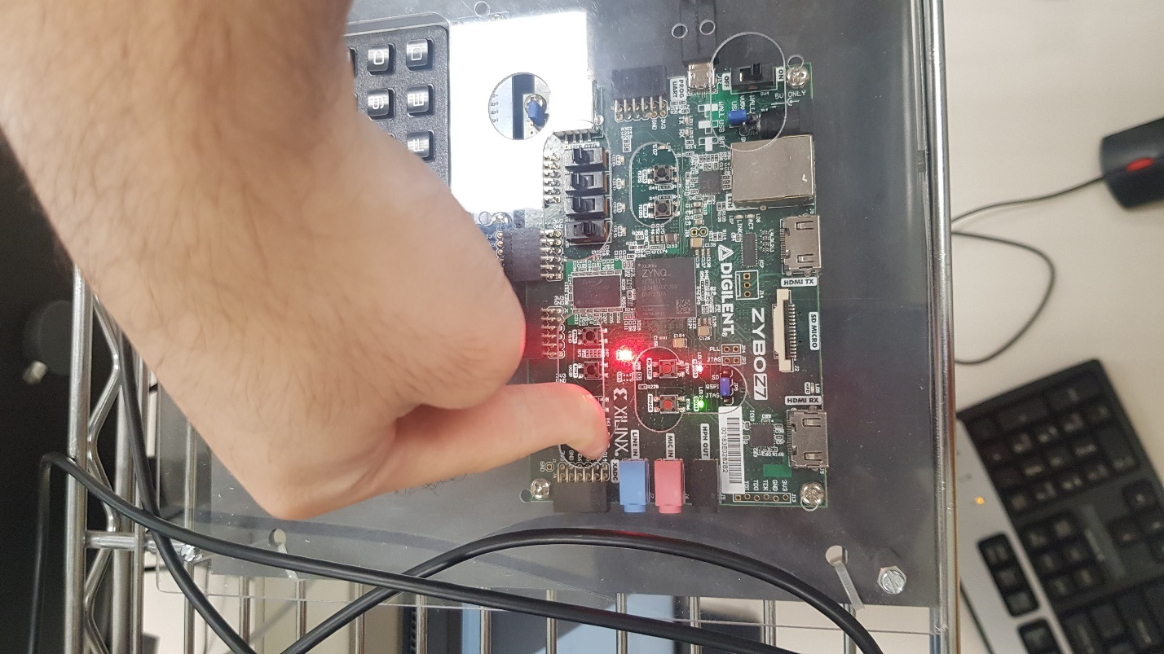
Figure 5: In this figure as you can see the security system displays the red light showing that the larm is going off and the inocrrect password and card have been entered
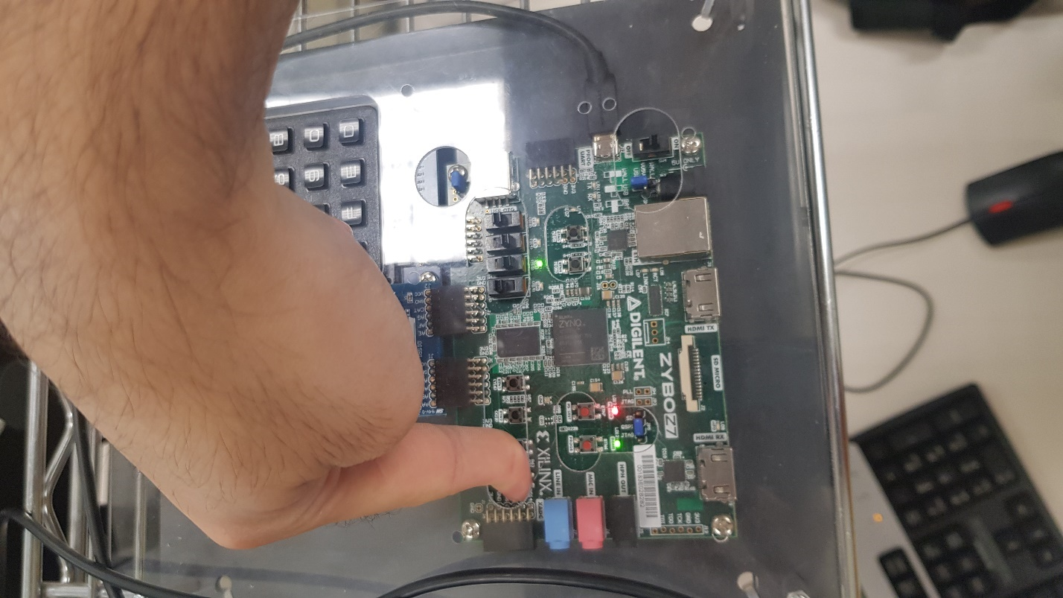
Figure 6: In this figure as you can see the security system displays a green light showing that the correct password and card have been used

